ABHINAV RANJAN

RA1911003010003

CSE A1 SECTION

SRMIST , KTR

**COMPILER DESIGN LAB**

***EXP 9 - COMPUTATION OF LR(0) ITEMS***

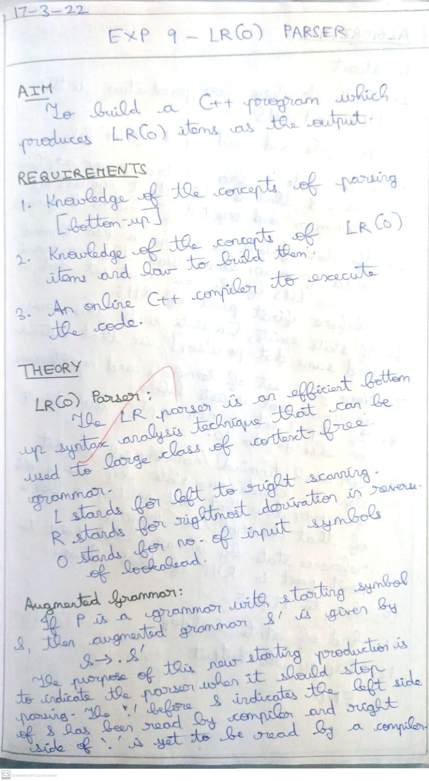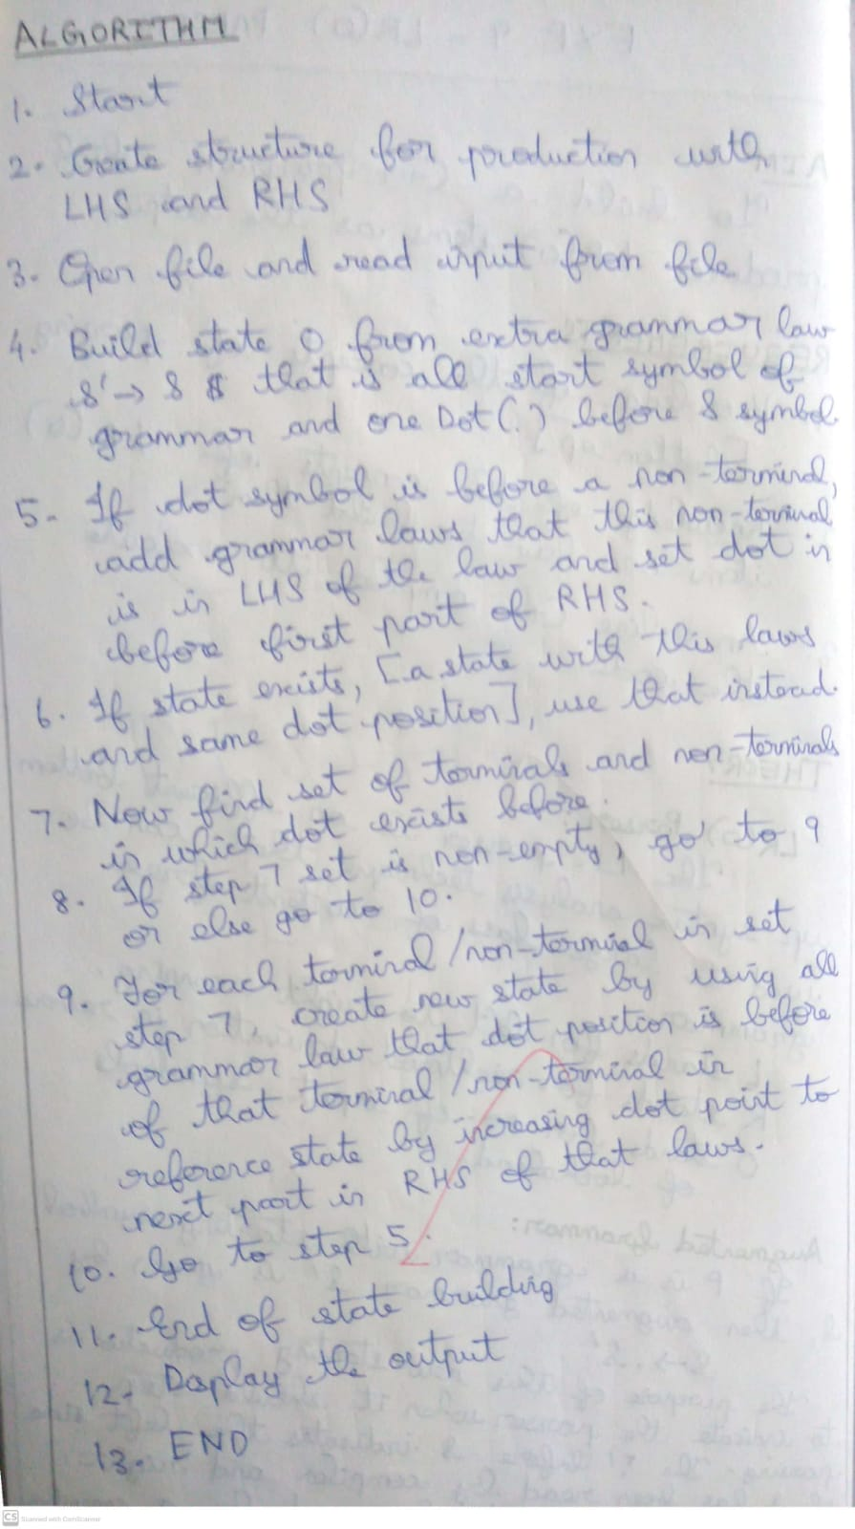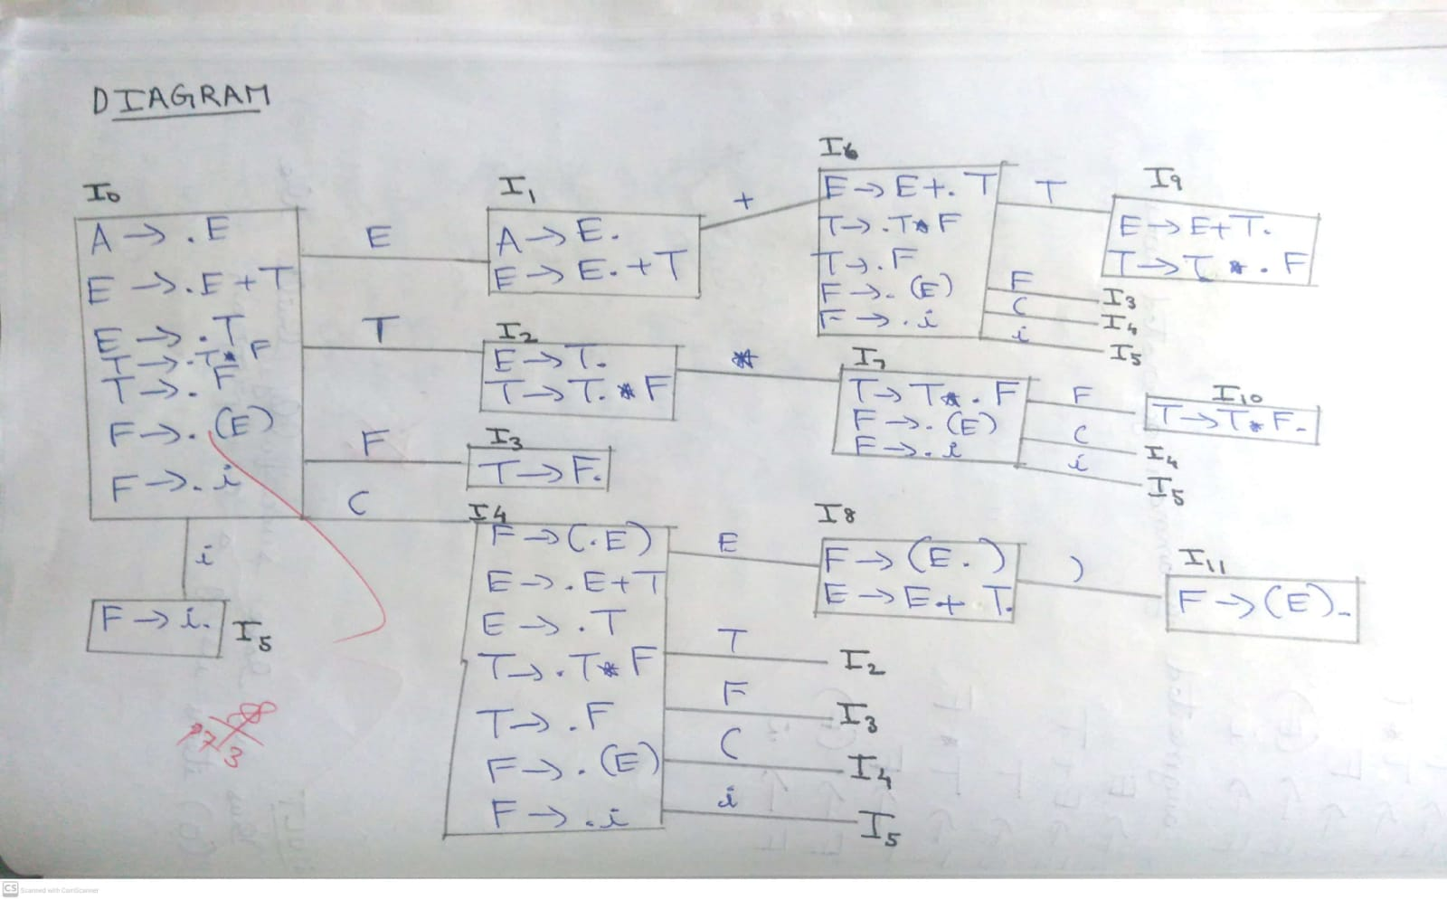

**SCREENSHOTS :**

